A Multi-objective Enhanced Tool for Optimal meal Recommendation system: MENTOR applied to elderly care facilities

Introduction

Background
The importance of balanced nutrition has become increasingly recognized as a critical determinant of public health outcomes and quality of life in modern society. This concern is particularly pressing as global demographic shifts toward aging populations have intensified the need for strategic nutritional interventions, with elderly individuals being particularly vulnerable to malnutrition and diet-related chronic diseases[1,2]. Chronic non-communicable diseases—including diabetes, cardiovascular disease, and metabolic syndrome—account for a substantial proportion of global morbidity and mortality, with dietary factors recognized as primary modifiable risk factors[3]. Evidence suggests that precision nutrition strategies can effectively prevent chronic disease onset and progression while promoting longevity and healthy aging[4].
This growing awareness has catalyzed a paradigm shift from population-level dietary guidelines to individualized nutritional recommendations that consider variability in nutritional requirements, chronic disease status, genetic predispositions, cultural preferences, and socioeconomic constraints[5,6]. For instance, personalized nutrition has demonstrated superior efficacy in managing conditions such as type 2 diabetes, where tailored dietary interventions significantly improve glycemic control and metabolic outcomes compared to standardized recommendations. Despite these advances in nutritional science and the clear benefits of personalized approaches, traditional menu planning methods remain inadequate for meeting the complex demands of modern dietary optimization.
Contemporary menu planning practices face substantial challenges that compromise their effectiveness and practical implementation. Traditional approaches rely heavily on manual methods requiring extensive time investment from nutritionists and dietitians, who must manually balance nutritional requirements, cost constraints, seasonal availability, cultural acceptability, and dietary variety—a cognitively demanding task that limits scalability and consistency[7]. Manual planning struggles to simultaneously optimize the multidimensional requirements of modern nutritional adequacy, which encompasses numerous micronutrients, macronutrients, dietary fiber, and bioactive compounds, each with specific recommended intake ranges, often resulting in suboptimal nutritional profiles or infeasible diet plans[8].
Furthermore, economic accessibility remains a critical barrier to nutritious diets, particularly for low-income populations and resource-constrained institutional settings such as elderly care facilities, yet manual planning methods inadequately address the trade-offs between nutritional adequacy and affordability[9,10]. Dietary diversity and sensory variety—essential for long-term dietary adherence and nutritional completeness—are often compromised in manually designed menus[11]. Perhaps most critically, manual planning introduces subjective biases in food selection and menu composition, leading to inconsistent recommendations across different planners and limited reproducibility, undermining the scientific rigor that should characterize evidence-based dietary planning[12].
The fundamental challenge lies in the inherent multi-objective nature of diet planning. Nutritional adequacy, cost minimization, dietary diversity, and meal acceptability represent competing objectives that traditional methods cannot systematically optimize[13,14]. The complexity of diet planning—characterized by multidimensional nutritional requirements, discrete food choices, nonlinear interactions between nutrients, and conflicting objectives—creates vast solution spaces that require advanced computational approaches for efficient and effective exploration[15,16].
Computer-based multi-objective optimization offers a transformative solution to these challenges. Such systems provide objectivity by eliminating subjective biases through evidence-based algorithmic decision-making, efficiency through rapid exploration of millions of potential menu combinations, and the capability to simultaneously optimize multiple competing objectives while satisfying complex nutritional and operational constraints. Moreover, computational approaches enable scalability to diverse populations and dietary requirements without proportional increases in human effort, ensure reproducibility through consistent and auditable optimization processes, and generate Pareto-optimal solution sets that reveal inherent trade-offs between objectives, empowering decision-makers with informed choices rather than arbitrary compromises.

Objective
This study develops a Multi-objective ENhanced Tool for Optimal diet Recommendation (MENTOR) that addresses the limitations of traditional diet planning through the integration of nutritional science principles with state-of-the-art multi-objective evolutionary algorithms (MOEAs). The system incorporates evidence-based dietary guidelines and reference intake standards while employing advanced optimization algorithms including NSGA-II, NSGA-III, SPEA2, and ε-MOEA to generate optimal meal plans. This hybrid approach ensures that optimized menus are both mathematically optimal and practically implementable in real-world settings.
Unlike traditional single-objective or weighted-sum approaches, MENTOR employs true multi-objective optimization to simultaneously address four critical dimensions. First, nutritional adequacy evaluates dietary compliance with established dietary reference intakes using a penalty-based scoring system that assesses deviations from recommended nutrient ranges for both macronutrients and micronutrients. Second, cost efficiency normalizes total meal costs against historical cost boundaries derived from institutional diet databases, promoting economic accessibility while maintaining nutritional quality. Third, menu harmony quantifies the compatibility of meal combinations based on co-occurrence patterns observed in historical diet data, identifying menu pairings that have been successfully implemented in practice. Fourth, dietary diversity employs the Simpson diversity index to measure the evenness of menu distribution across the planning period, ensuring variety and preventing monotonous food choices.
To address these competing objectives simultaneously, the system generates Pareto-optimal solution sets representing the best achievable trade-offs among objectives, enabling decision-makers to select solutions aligned with specific priorities—whether minimum cost, maximum diversity, or balanced trade-offs—based on contextual requirements rather than arbitrary subjective preferences. To ensure practical applicability, MENTOR incorporates realistic constraints including ingredient availability derived from institutional food databases, portion size specifications with 0.6-1.0 ratio constraints to allow flexible serving adjustments, and meal structure conventions observed in historical diet planning practices.
The tool has been applied to elderly care facility menu planning, addressing the unique nutritional needs and dietary preferences of this vulnerable population. Beyond the system development itself, a key contribution of this research is the systematic performance comparison of four state-of-the-art MOEAs on an identical, standardized diet optimization problem. While previous studies have applied various algorithms to diet planning, insufficient benchmarking exists to guide practitioners in algorithm selection. This study evaluates NSGA-II, NSGA-III, SPEA2, and ε-MOEA using comprehensive performance metrics including hypervolume, spacing, diversity, convergence, and computational efficiency, providing evidence-based recommendations for algorithm selection in practical dietary planning applications. Through this integrated approach combining algorithmic innovation, domain expertise, and rigorous empirical evaluation, this work advances both the theoretical foundations and practical implementation of computational diet optimization for elderly care facilities.

Related work

Classical Single-Objective Optimization
The systematic application of mathematical optimization to dietary planning originated with George Stigler's seminal 1945 work addressing the "Diet Problem"—the challenge of identifying minimum-cost food combinations satisfying nutritional requirements for U.S. military personnel[17]. Stigler manually computed a solution through iterative heuristic methods, demonstrating the feasibility of systematic diet optimization[18]. Subsequently, George Dantzig's development of the simplex algorithm for Linear Programming (LP) validated Stigler's approach, finding a solution remarkably close to Stigler's manual result[19]. This pioneering work established the foundational framework for computational diet optimization that persists today.
Early research concentrated on Linear Programming with single-objective optimization, treating cost minimization as the sole objective while constraining nutritional adequacy to minimum threshold requirements[20]. LP formulations model diet planning by minimizing total cost as the sum of ingredient costs multiplied by serving quantities, subject to constraints on minimum and maximum nutrient intakes and non-negativity requirements. This approach successfully addressed nutrient deficiency prevention in resource-constrained settings and provided theoretically optimal solutions with guaranteed global optimality for convex problems[21].
Despite mathematical elegance, single-objective LP-based diet optimization suffered from severe practical limitations. Optimization frequently produced monotonous diets with minimal food diversity, as algorithms selected the most cost-efficient nutrient sources regardless of palatability or variety[12]. These approaches provided no consideration of taste preferences, dietary patterns, or food aversions, resulting in theoretically optimal but practically unacceptable diets[22]. The limitations of single-objective approaches led to the recognition that diet optimization is inherently multi-objective, involving competing goals such as nutritional adequacy, cost-effectiveness, dietary variety, and cultural acceptability that cannot be reduced to a single scalar optimization function without arbitrary and subjective weighting decisions.

Multi-objective Optimization in Diet Planning
Research began incorporating diverse objectives beyond cost minimization, transforming nutrition from constraint satisfaction to optimization objectives. These expanded formulations included nutritional balance optimization through maximizing adequacy scores and minimizing deviations from recommended intake ranges, dietary diversity maximization by increasing food variety across and within food groups, environmental sustainability considerations including greenhouse gas emissions and resource consumption, and personal preference satisfaction incorporating individual taste and habitual dietary patterns[14,23,24].
Initial multi-objective approaches employed conventional optimization techniques. Weighted-sum methods combine multiple objectives through weighted aggregation into a single composite function. The ε-constraint method optimizes one primary objective while constraining others to acceptable threshold levels. Goal programming minimizes deviations from predetermined target values across multiple objectives. Abejón et al. optimized Spanish diets considering nutritional contribution, greenhouse gas emissions, and cost using distance-to-target methods, demonstrating feasible low-carbon diets with acceptable nutritional profiles[25], while Canadian research applied weighted-sum and ε-constraint approaches to design nutritionally adequate, affordable food baskets promoting public health[10]. However, these traditional methods faced computational complexity with exponential growth in requirements as problem scale increased, struggled with mixed discrete-continuous variable characteristics inherent to food selection and portion sizing, provided limited Pareto front exploration capabilities, and introduced weight-dependent subjectivity through arbitrary parameter selection.

Metaheuristic-Based Approaches
The inherent complexity of diet optimization problems necessitated metaheuristic solutions capable of comprehensive solution space exploration and real-time decision support[26]. Diet optimization problems exhibit computational hardness due to their combinatorial nature, where selecting meal combinations from large food databases creates exponentially growing solution spaces. These problems involve mixed discrete-continuous variables for food selection and portion sizing, nonlinear nutritional interactions between ingredients, and multiple competing constraints that must be satisfied simultaneously. Initial metaheuristic applications employed single-objective algorithms with objective aggregation, including Genetic Algorithms with weighted-sum methods[27], Particle Swarm Optimization achieving effective performance in dietary planning[28], and hybrid approaches combining PSO with Simulated Annealing for enhanced local search and global exploration balance[29].
State-of-the-art methodologies emerged with sophisticated multi-objective evolutionary algorithms (MOEAs). NSGA-II employs fast non-dominated sorting with crowding distance for diversity maintenance and has been extensively applied to diet optimization with proven effectiveness in balancing nutritional adequacy, cost, and diversity, demonstrating superior performance in two-to-three objective diet problems[30]. NSGA-III extends NSGA-II for many-objective optimization involving more than three objectives using reference point-based selection, proving particularly effective for high-dimensional diet problems[31]. SPEA2 utilizes strength-based fitness assignment with external archive maintenance for preserving high-quality solutions, effective for complex Pareto front geometries in diet optimization[32]. ε-MOEA employs the ε-dominance concept for controlled solution distribution and computational efficiency, ensuring well-spread Pareto fronts with bounded archive sizes advantageous for large-scale menu planning applications.
These metaheuristic MOEAs offer distinct advantages for diet optimization. They enable simultaneous Pareto front exploration in a single optimization run, generating multiple non-dominated solutions that reveal inherent trade-offs between competing objectives. Unlike traditional methods, MOEAs can find optimal solutions on complex non-convex trade-off surfaces without requiring a priori weight specifications, thus eliminating subjective bias in objective prioritization. They effectively handle the nonlinear discrete and mixed-variable constraints characteristic of food selection problems and demonstrate scalability to large-scale problems involving hundreds of food items and dozens of nutrients.

Application Domain Expansion and Specialized Research
Building on these algorithmic advances, research has expanded to specialized dietary optimization for specific populations and contexts. Disease-specific approaches have applied multi-objective optimization to diabetic patient diets, simultaneously addressing glucose control, nutritional balance, and economic efficiency through evolutionary algorithms[8,16,29]. Personalized nutrition strategies targeting chronic disease prevention in elderly populations have been developed using multi-objective frameworks that integrate individual health profiles with dietary recommendations[1,4]. Institutional applications have addressed menu planning challenges for university students, elderly care facilities, therapeutic feeding programs for malnourished children, and workplace cafeterias using various multi-objective optimization approaches[7].
Modern diet optimization frameworks increasingly integrate multidimensional personalization factors beyond basic nutritional requirements. Individual metabolic characteristics including basal metabolic rate, physical activity levels, and anthropometric measurements inform caloric and macronutrient targets[5]. Disease management considerations for conditions such as diabetes, hypertension, cardiovascular disease, and renal disease require specialized nutrient restrictions and therapeutic dietary modifications[6]. Economic constraints at both individual and institutional levels necessitate cost-aware optimization that balances nutritional quality with affordability. For institutional settings such as elderly care facilities, operational factors including ingredient availability in local food supply systems, kitchen equipment capabilities, staff culinary expertise, and meal service logistics significantly influence the feasibility and acceptability of optimized diet plans.
  - 고령 추가

Current Research Limitations and Study Contributions
Despite substantial progress in diet optimization research, several critical gaps remain. First, existing studies predominantly focus on nutritional adequacy, cost, and diversity while neglecting menu compatibility based on historical dietary patterns, which is essential for meal acceptability, particularly in elderly care settings where established food combinations influence dietary intake. Second, insufficient systematic comparison of multiple MOEAs on identical diet optimization problems with standardized performance metrics limits evidence-based algorithm selection in practice. Third, a lack of accessible, user-friendly tools integrating expert nutritional knowledge with advanced optimization algorithms specifically designed for elderly care facilities hinders real-world dietary planning applications.
This study addresses these gaps through three main contributions. First, we develop a comprehensive four-objective optimization framework that incorporates menu harmony based on historical co-occurrence patterns alongside nutrition, cost, and diversity, with specific consideration for elderly dietary needs and preferences. Second, we conduct systematic empirical comparison of four state-of-the-art MOEAs using standardized performance metrics to provide evidence-based algorithm selection guidance for elderly care facility menu planning. Third, we implement MENTOR, a practical optimization tool designed specifically for elderly care facilities that integrates expert nutritional knowledge, realistic operational constraints, and user-friendly interfaces to bridge the gap between algorithmic optimization and real-world dietary planning practice.

Multi-objective Enhanced Tool for Optimal Diet Recommendation

Problem Definition and Formulation
The diet optimization problem represents a complex multi-objective optimization challenge in which multiple competing objectives must be balanced simultaneously. These objectives include nutritional adequacy, cost-effectiveness, menu compatibility, and dietary diversity. While traditional approaches often focus on optimizing a single objective, such as minimizing cost or maximizing nutritional value, our formulation uniquely captures the interdependencies between these objectives through a comprehensive mathematical framework that enables concurrent optimization of all factors.

Objective 1: Nutritional Score
The nutritional score (NS) quantifies how well a diet meets established nutritional requirements over a specified planning period. The evaluation employs a daily penalty-based scoring system where each day starts with a base score of 100, from which deductions are systematically applied for deviations from nutritional guidelines.
Let $N$ denote the set of essential nutrients to be monitored. For each nutrient $n ∈ N$, the lower and upper bounds of recommended daily intake are denoted as $L\left(n\right)$ and $U\left(n\right)$, respectively. The nutrient-specific importance weight is represented by W(n), while $C_{d}\left(n\right)$ indicates the actual nutrient content for day $d$.
The nutritional evaluation process begins with daily nutrient aggregation, where for each day $d$, the total nutrient content is calculated by summing across all three meals (breakfast, lunch, dinner). This aggregation is formalized as:
$$C_{d}\left(n\right)=\sum_{k=1}^{3}{\sum_{m∈M_{k}}{B_{m}\left(n\right)∙r_{m}}}$$where $M_{k}$ represents the set of menus in meal k, $B_{m}\left(n\right)$ is the base nutrient content of menu $m$ for nutrient $n$, and $r_{m}$ is the serving ratio for menu $m$. This formulation accounts for the variable serving sizes that allow flexibility in portion control while maintaining nutritional tracking accuracy.
The daily nutritional score $NS_{d}$ is subsequently calculated using a penalty-based deduction system starting from a base score of 100. For each day $d$, deviations from nutritional guidelines result in penalties according to:
$$NS_{d}=max\left(0, 100-\sum_{n∈N}{P_{d}(N)}\right)$$The penalty for each nutrient $n$ on day $d$ is defined as:
$$P_{d}(N)= \min\left(P_{max},\left|\frac{C_{d}\left(n\right)-M_{d}\left(n\right)}{M_{d}\left(n\right)}\right|∙W\left(n\right)∙P_{max}\right)$$where the reference value $M_{d}\left(n\right)$ for penalty calculation is determined by comparing daily consumption with recommended bounds. If the daily consumption $C_{d}\left(n\right)$ falls below the minimum recommended value $L\left(n\right)$, then $M_{d}\left(n\right)=L\left(n\right)$ and penalties are applied for nutrient deficiency. If consumption exceeds the maximum recommended value $U\left(n\right)$, then $M_{d}\left(n\right)=U\left(n\right)$ and penalties are applied for nutrient excess. When consumption falls within the acceptable range, $M_{d}\left(n\right)=C_{d}\left(n\right)$, which results in zero penalty as the nutrient intake meets the recommended guidelines. The term $P_{max}= \frac{100}{\left|N\right|}$ represents the maximum penalty that can be applied per nutrient, ensuring no single nutrient dominates the overall score. This balanced approach prevents extreme penalties from any individual nutrient while maintaining sensitivity to nutritional deviations.
The final nutritional score (NS) for the complete diet plan is computed as the arithmetic mean across all days in the planning period:
$$NS=\frac{1}{D}\sum_{d=1}^{D}{NS_{d}}$$where $D$ represents the number of days in the planning period. Since each daily score is bounded between 0 and 100, the resulting average score naturally falls within the same range, with higher scores indicating better nutritional adequacy and compliance with established dietary guidelines.

Objective 2: Cost Score
The cost score (CS) assesses the affordability of the diet by normalizing the total meal cost against historical cost boundaries. The evaluation process begins by calculating the total cost for each diet (${CS}_{raw})$ as the sum of all ingredient costs across all meals, with each ingredient cost adjusted by the corresponding menu's serving ratio to account for variable portion sizes.
The normalization process utilizes historical cost data from the diet database to establish meaningful cost boundaries. The minimum cost reference (${CS}_{min}$) is determined as the sum of the top $T$ least expensive meal costs from the database, where $T=3×D$ represents the total number of meal instances across all days, representing the most economical meal combination achievable. Conversely, the maximum cost reference (${CS}_{max})$ is calculated as the sum of the top $T$ most expensive meal costs, establishing the upper boundary of the cost spectrum.
The cost score is then computed using a reverse normalization approach where lower costs receive higher scores, reflecting the desirability of more affordable diet options:
$$CS= 100-\frac{{CS}_{raw}- {CS}_{min}}{{CS}_{max}-{CS}_{min}}×100$$This formulation ensures that the cost score ranges from 0 to 100, where a score of 100 represents the most cost-effective diet, and a score approaching 0 indicates higher cost diets. The linear scaling provides intuitive interpretation while maintaining proportional relationships between different cost levels across the feasible range.

Objective 3: Harmony Score
The harmony score (HS) measures the compatibility of menu item combinations within meals based on their historical co-occurrence patterns observed in the diet database. This objective recognizes that certain menu combinations are more palatable and culturally acceptable when they appear together frequently in established meal plans.
The evaluation process begins by constructing a harmony matrix $H$ from historical diet data, where each element $H_{i,j}$ represents the frequency of co-occurrence between menu items i and j across all recorded meals. This matrix captures both explicit pairings within individual meals and implicit relationships between menus that commonly appear in the same diet plans.
For a given weekly diet plan, the harmony evaluation examines all possible menu pairs across the entire week, not limited to individual meals. The weekly menu sequence is represented as a collection of menu items $\left\{m_{1}, m_{2}, …, m_{T}\right\}$. The raw harmony score is calculated by summing the co-occurrence frequencies for all unique pairs:
$${HS}_{raw}=\sum_{i=1}^{T-1}{\sum_{j=i+1}^{T}{H_{m_{i}, m_{j}}}}$$The average harmony per pair is then computed by dividing by the total number of pairs, and subsequently normalized against the maximum observed co-occurrence frequency in the harmony matrix to ensure scores remain within a consistent range:
$$HS=\frac{{HS}_{raw}}{\left|Q\right|}∙\frac{100}{{HS}_{max}}$$where $\left|Q\right|= \frac{T\left(T-1\right)}{2}$ represents the total number of unique pairs in the weekly diet, and ${HS}_{max}$ is the maximum co-occurrence frequency observed in the harmony matrix. The harmony score ranges from 0 to 100, where higher scores indicate menu combinations that align more closely with historically successful meal pairings.

Objective 4: Diversity Score
The diversity score (DS) evaluates the distribution evenness of menu items across the diet plan using the Simpson diversity index, which provides a robust measure of how uniformly different menu types are represented throughout the weekly plan. This objective ensures that the optimized diet avoids excessive repetition while maintaining variety in food choices.
The evaluation process begins by analyzing the frequency distribution of all menu items across the complete weekly diet plan. For each unique menu item $m$ in the diet, the proportion $p_{m}$ is calculated as the ratio of its occurrence count to the total number of menu instances:
$$p_{m}=\frac{f_{m}}{\sum_{u=1}^{\left|M\right|}{f_{u}}}$$where $\left|M\right|$ represents the total number of unique menu items appearing in the diet plan, and $f_{m}$ denotes the frequency of menu item $m$ across all meals and days.
The Simpson diversity index (${DS}_{raw}$) is subsequently computed by summing the squared proportions of all menu items, providing a measure of concentration that increases with menu repetition:
$${DS}_{raw}= \sum_{m=1}^{\left|M\right|}{p_{m}^{2}}$$The final diversity score transforms this concentration measure into an interpretable score where higher values indicate greater diversity:
$$DS= \left(1-{DS}_{raw}\right) × 100$$This formulation ensures that the diversity score ranges from 0 to 100, where scores approaching 100 indicate highly diverse diet plans with evenly distributed menu items, while lower scores suggest diets dominated by repetitive menu choices. The Simpson index approach provides mathematical rigor while maintaining intuitive interpretation of dietary variety.

Optimization Algorithms

Non-dominated Sorting Genetic Algorithm II (NSGA-II)
The Non-dominated Sorting Genetic Algorithm II (NSGA-II) employs a fast non-dominated sorting approach combined with crowding distance calculations to maintain population diversity while converging toward the Pareto front. The algorithm begins with an initial population of size N and iteratively evolves solutions through crossover and mutation operations.
During each generation, the algorithm combines the current population with newly generated offspring to form a combined population of size 2N. Fast non-dominated sorting categorizes solutions into multiple fronts based on dominance relationships, where the first front contains all non-dominated solutions. The selection process prioritizes solutions from better fronts, and when a front cannot be fully included due to population size constraints, crowding distance serves as a tie-breaking mechanism to preserve diversity by favoring solutions in less crowded regions of the objective space.

Algorithm 1: NSGA-II
Input: Population size N, Maximum generations $G_{max}$
Output: Final population of non-dominated solutions
1 | Initialize population $P_{0}$ of size N
2 | g ← 0
3 | while (g < $G_{max}$) do
4 |  | $Q_{g} ← Create offspring from P_{g}$
5 |  | $$R_{g}←P_{g}∪ Q_{g}$$
6 |  | $$F ← Fast non-dominated sort of R_{g}$$
7 |  | $$P_{g+1}← ∅ and i ← 1$$
8 |  | $$while \left|P_{g+1}\right|+\left|F_{i}\right|≤N do$$
9 |  |  | $$P_{g+1} ← P_{g+1} ∪ F_{i}$$
10 |  |  | $$i ← i+1$$
11 |  | end while
12 |  | $$d_{j} ← Calculate crowding distance for each j in F_{i}$$
13 |  | Sort $F_{i}$ by $d_{j}$in descending order
14 |  | $P_{g+1}←P_{g+1} ∪F_{i}\left[1:N-\left|P_{g+1}\right|\right]$
15 |  | g ← g + 1
16 | end while
17 | return $P_{g}$

Non-dominated Sorting Genetic Algorithm III (NSGA-III)
The Non-dominated Sorting Genetic Algorithm III (NSGA-III) extends NSGA-II by incorporating reference point-based selection mechanisms specifically designed for many-objective optimization problems. While maintaining the fast non-dominated sorting approach, NSGA-III replaces crowding distance with a niching strategy that uses predefined reference points to guide population diversity.
The algorithm generates a set of well-distributed reference points on a unit hyperplane and associates each solution with its closest reference point after normalizing objectives using ideal and nadir points. The selection process maintains balance by preferring reference points with fewer associated solutions, thereby promoting uniform distribution across the objective space. This approach proves particularly effective for problems with four or more objectives where crowding distance may lose effectiveness.

Algorithm 2: NSGA-III
Input: Population size N, Maximum generations $G_{max}$, Number of reference points R
Output: Final population of non-dominated solutions
1 | Initialize population $P_{0}$ of size N
2 | Z ← Generate reference points with size R
3 | g ← 0
4 | while (g < $G_{max}$) do
5 |  | $Q_{g} ← Create offspring from P_{g}$
6 |  | $$R_{g}←P_{g}∪ Q_{g}$$
7 |  | $$F ← Fast non-dominated sort of R_{g}$$
8 |  | $$P_{g+1}← ∅ and i ← 1$$
9 |  | $$while \left|P_{g+1}\right|+\left|F_{i}\right|≤N do$$
10 |  |  | $$P_{g+1} ← P_{g+1} ∪ F_{i}$$
11 |  |  | $$i ← i+1$$
12 |  | end while
13 |  | $$Z_{Ideal}← Ideal point of R_{g} and Z_{Nadir}← Nadir point of R_{g}$$
14 |  | π ← Normalize objectives of $F_{i}$ using $Z_{ideal} and$ $Z_{Nadir}$
15 |  | $ρ$ ← Associate each solution in $F_{i}$ to references points in Z
16 |  | $n_{ρ}$ ← Count solutions for each reference point in $ρ$
17 |  | $P_{g+1}$ ← $P_{g+1} ∪{Niching selection from F}_{i} using ρ and n_{ρ}$
18 |  | g ← g + 1
19 | end while
20 | return $P_{g}$

Strength Pareto Evolutionary Algorithm 2 (SPEA2)
The Strength Pareto Evolutionary Algorithm 2 (SPEA2) maintains an external archive of non-dominated solutions while using fitness assignment based on strength and density information. The algorithm distinguishes itself through its sophisticated fitness calculation that combines domination strength with local density estimation using k-nearest neighbor distances.
Each solution's strength corresponds to the number of solutions it dominates, while its raw fitness equals the sum of strengths of all solutions that dominate it. Density estimation provides fine-grained discrimination between solutions with identical raw fitness values. The algorithm maintains an archive of fixed size through environmental selection that preserves non-dominated solutions and uses truncation operators to maintain archive size constraints when necessary.

Algorithm 3: SPEA2
Input: Population size N, Archive size $A_{size}$, Maximum generations $G_{max}$
Output: Final population of non-dominated solutions
1 | Initialize population $P_{0}$ of size N
2 | Initialize empty archive $A_{0}$
3 | g ← 0
4 | while (g < $G_{max}$) do
5 |  | $$R_{g}←P_{g}∪ A_{g}$$
6 |  | $$s_{i}←Calculate strength of i in R_{g}$$
7 |  | $${rf}_{i}←Calculate raw fitness of i in R_{g} based on strength values$$
8 |  | $$ρ_{i}←Calculate density of i in R_{g} using k-th nearest neighbor$$
9 |  | $$F_{i}←{rf}_{i}+ ρ_{i}$$
10 |  | $$A_{g+1} ← Environmental selection (R_{g}, F_{i}, A_{size})$$
11 |  | if $\left|A_{g+1}\right| < A_{size}$ then
12 |  |  | $$Fill A_{g+1} with best individuals from R_{g}$$
13 |  | else if $\left|A_{g+1}\right| > A_{size}$ then
14 |  |  | Truncate $A_{g+1}$ using clustering
15 |  | end if
16 |  | $$P_{g+1} ← Mating selection from A_{g+1}$$
17 |  | $$g ←g+1$$
18 | end while
19 | return $A_{g}$

Epsilon Multi-Objective Evolutionary Algorithm (ε-MOEA)
The Epsilon Multi-Objective Evolutionary Algorithm (ε-MOEA) employs an epsilon-dominance archiving strategy that divides the objective space into hyperboxes of size epsilon, with each hyperbox containing at most one solution. This approach provides theoretical convergence guarantees while maintaining bounded archive sizes regardless of the problem's Pareto front characteristics.
The algorithm operates by mapping each solution to a hyperbox based on its objective values divided by epsilon parameters. When multiple solutions map to the same hyperbox, only the epsilon-dominating solution is retained, ensuring archive quality while controlling size. The epsilon-dominance concept relaxes strict dominance requirements, allowing solutions to be considered equivalent within epsilon tolerance, which proves particularly useful for maintaining practical archive sizes in complex optimization landscapes.

Algorithm 4: ε-MOEA
Input: Population size N, Archive size $A_{size}$, Maximum generations $G_{max}$, Epsilon values ε
Output: Final population of non-dominated solutions
1 | Initialize population $P_{0}$ of size N
2 | Initialize empty archive $A_{0}$
3 | ε ← $\left\{ε_{1},ε_{2}, ε_{3}, ε_{4}\right\}$ for each objective
4 | g ← 0
5 | while (g < $G_{max}$) do
6 |  | $Q_{g}$ ← Create offspring ($P_{g}$)
7 |  | for each individual $i$ in $Q_{g}$ do
8 |  |  |  | $$B_{i} ← ⌊O(i)/ε⌋$$
9 |  |  |  | if $B_{i}$ not in $A_{g}$ then
10 |  |  |  |  | $$A_{g}← A_{g}∪$$
11 |  |  |  | else
12 |  |  |  |  | if i ε-dominates $A_{g}$[$B_{i}$] then
13 |  |  |  |  |  | Replace $A_{g}$[$B_{i}$] with i
14 |  |  |  |  | end if
15 |  |  |  | end if
16 |  | end for
17 |  | if $\left|A_{g}\right|$ > $A_{size}$ then
18 |  |  | Truncate $A_{g}$ using clustering
19 |  | end if
20 |  | $$P_{g+1} ← Mating selection from A_{g+1}$$
21 |  | $$g ← g+1$$
22 | end while
23 | return $A_{g}$

Experimental study

Dataset Description
정선 요양원

Performance Metrics

Comparison of the algorithms
The performance evaluation was conducted using four state-of-the-art multi-objective evolutionary algorithms: NSGA-II, NSGA-III, SPEA2, and ε-MOEA. Each algorithm was executed 10 independent runs with identical initial conditions to ensure statistical robustness and account for stochastic variation inherent in evolutionary algorithms. All algorithms shared standardized parameters: population size of 150 individuals, maximum generations of 100, crossover probability of 0.8, and mutation probability of 0.3.
Performance assessment employed five complementary metrics: hypervolume (Pareto front coverage), spacing (solution distribution uniformity), diversity (objective space extent), convergence (solution quality improvement from initial population), and computational efficiency (execution time in seconds). Statistical significance was evaluated using non-parametric tests (Shapiro-Wilk for normality, Kruskal-Wallis for overall differences, and Mann-Whitney U for pairwise comparisons) due to the unknown distribution characteristics of performance metrics.

Evaluation by dietitians
IRB 내용

Statistical Analysis
To evaluate the statistical significance of the performance differences between algorithms, we assessed distributional normality using the Shapiro-Wilk test (α = 0.05). Results revealed significant deviations from normality for multiple metrics, we employed non-parametric statistical tests. First, the Kruskal-Wallis H-test was performed to determine if there were statistically significant differences among all algorithms, followed by pairwise Mann-Whitney U test with Bonferroni correction (α = 0.05/6 = 0.0083) for pairwise comparisons. The effect sizes were quantified using Cliff's Delta (δ), with thresholds: |δ| < 0.147 (negligible), 0.147 ≤ |δ| < 0.330 (small), 0.330 ≤ |δ| < 0.474 (medium), |δ| ≥ 0.474 (large) (Romano et al., 2006).

Results

Overall Performance Comparison
To comprehensively evaluate the four multi-objective evolutionary algorithms (NSGA-II, NSGA-III, SPEA2, and ε-MOEA) for dietary optimization, we assessed performance across five complementary metrics: hypervolume, spacing, diversity, convergence, and execution time. Table 1 summarizes the mean performance and standard deviation for each algorithm across all metrics based on 10 independent runs.

Table 1. Comparative Performance of Multi-Objective Optimization Algorithms (Mean ± Standard Deviation, n=10)
Metric | NSGA-II | NSGA-III | SPEA2 | ε-MOEA
Hypervolume | 0.382 ± 0.007 | 0.381 ± 0.013 | 0.384 ± 0.007 | 0.357 ± 0.021
Spacing | 0.530 ± 0.357 | 0.388 ± 0.251 | 0.436 ± 0.375 | 1.026 ± 0.400
Diversity | 0.994 ± 0.345 | 1.005 ± 0.329 | 1.153 ± 0.507 | 1.841 ± 0.561
Convergence | 0.221 ± 0.051 | 0.232 ± 0.054 | 0.295 ± 0.095 | 0.334 ± 0.091
Time (s) | 82.1 ± 183.4 | 261.3 ± 305.4 | 17.4 ± 13.4 | 667.1 ± 203.4
Note: Bold values indicate the best performance for each metric, with arrows indicating whether higher or lower values represent superior performance.

SPEA2 emerged as the overall leader, achieving the highest hypervolume (0.384 ± 0.007) while dramatically outperforming all competitors in computational efficiency with an average execution time of 17.4 ± 13.4 seconds. This represents a speed advantage of 4.7-fold compared to NSGA-II, 15.0-fold compared to NSGA-III, and 38.4-fold compared to ε-MOEA. The low standard deviation in both hypervolume (0.007) and execution time (13.4 seconds) demonstrates exceptional consistency across independent runs, indicating that SPEA2 reliably delivers high-quality solutions with predictable computational cost regardless of initial population randomness.
NSGA-II exhibited the fastest convergence (0.221 ± 0.051), indicating superior ability to rapidly approach the true Pareto front. Combined with competitive hypervolume performance (0.382 ± 0.007), NSGA-II represents a balanced choice for applications prioritizing convergence speed. However, the extremely large standard deviation in execution time (183.4 seconds, 2.2 times the mean) reveals high runtime variability, with some runs completing in under 20 seconds while others exceeded 600 seconds.
NSGA-III achieved the most uniform solution distribution with a spacing value of 0.388 ± 0.251, outperforming SPEA2 and NSGA-II by 11% and 27%, respectively. However, this advantage comes at substantial computational cost, with execution time averaging 261.3 seconds and high variance (SD: 305.4 seconds).
In contrast, ε-MOEA consistently underperformed across all critical metrics, exhibiting the lowest hypervolume (0.357 ± 0.021), poorest solution uniformity (spacing: 1.026 ± 0.400), slowest convergence (0.334 ± 0.091), and longest execution time (667.1 ± 203.4 seconds, over 11 minutes). The exceptionally high diversity score (1.841 ± 0.561) reflects excessive exploration without adequate exploitation, suggesting that the ε-dominance mechanism struggles to balance exploration-exploitation within the 100-generation limit.

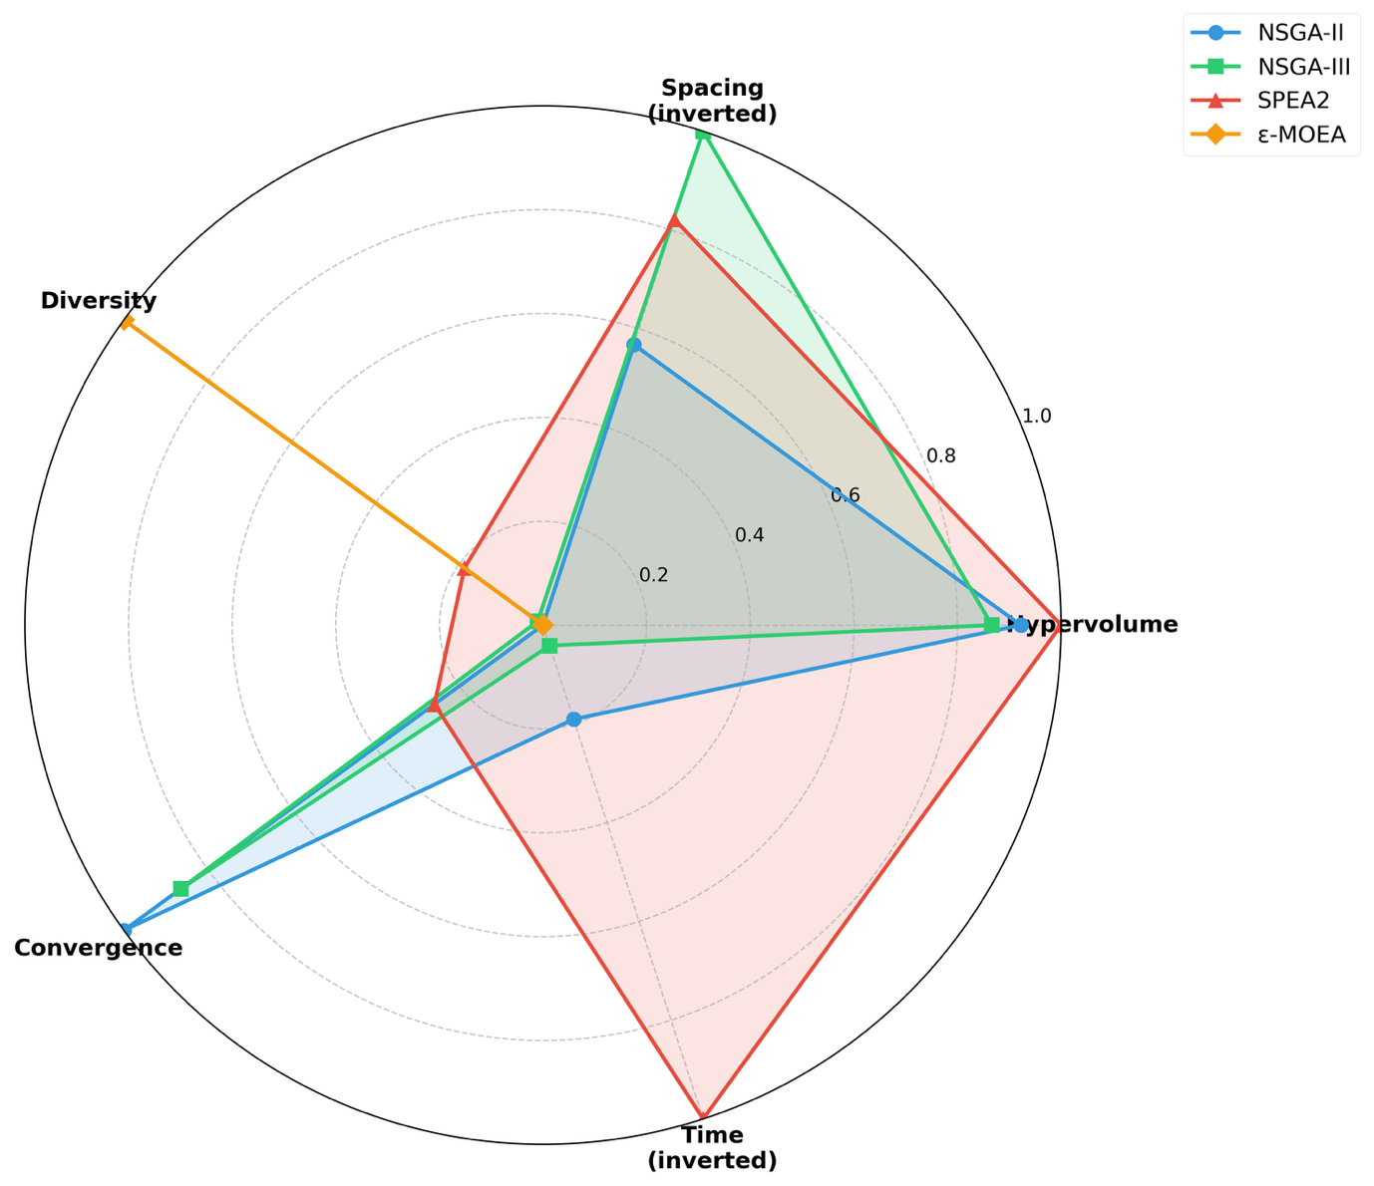
Figure 1. A radar chart with normalized performance scores across all five metrics. The spacing and execution time inverted for interpretability such that larger areas consistently represent better performance.

Figure 1 provides an intuitive comparison of algorithmic strengths and weaknesses across multiple dimensions simultaneously. SPEA2's radar profile (red) covers the largest area, excelling particularly in hypervolume and execution time while maintaining competitive performance in convergence and diversity. The only relative weakness is spacing, though this deficiency is modest compared to its overall superiority and does not substantially compromise practical utility for decision support applications. NSGA-II and NSGA-III (blue and green) display similar pentagon shapes, with NSGA-II slightly extending toward convergence and NSGA-III toward spacing. ε-MOEA (orange) exhibits the smallest enclosed area, with pronounced deficiencies in hypervolume, convergence, and execution time. The only dimension where ε-MOEA extends substantially is diversity, confirming its tendency toward exploration at the expense of convergence.

Optimization Quality and Consistency
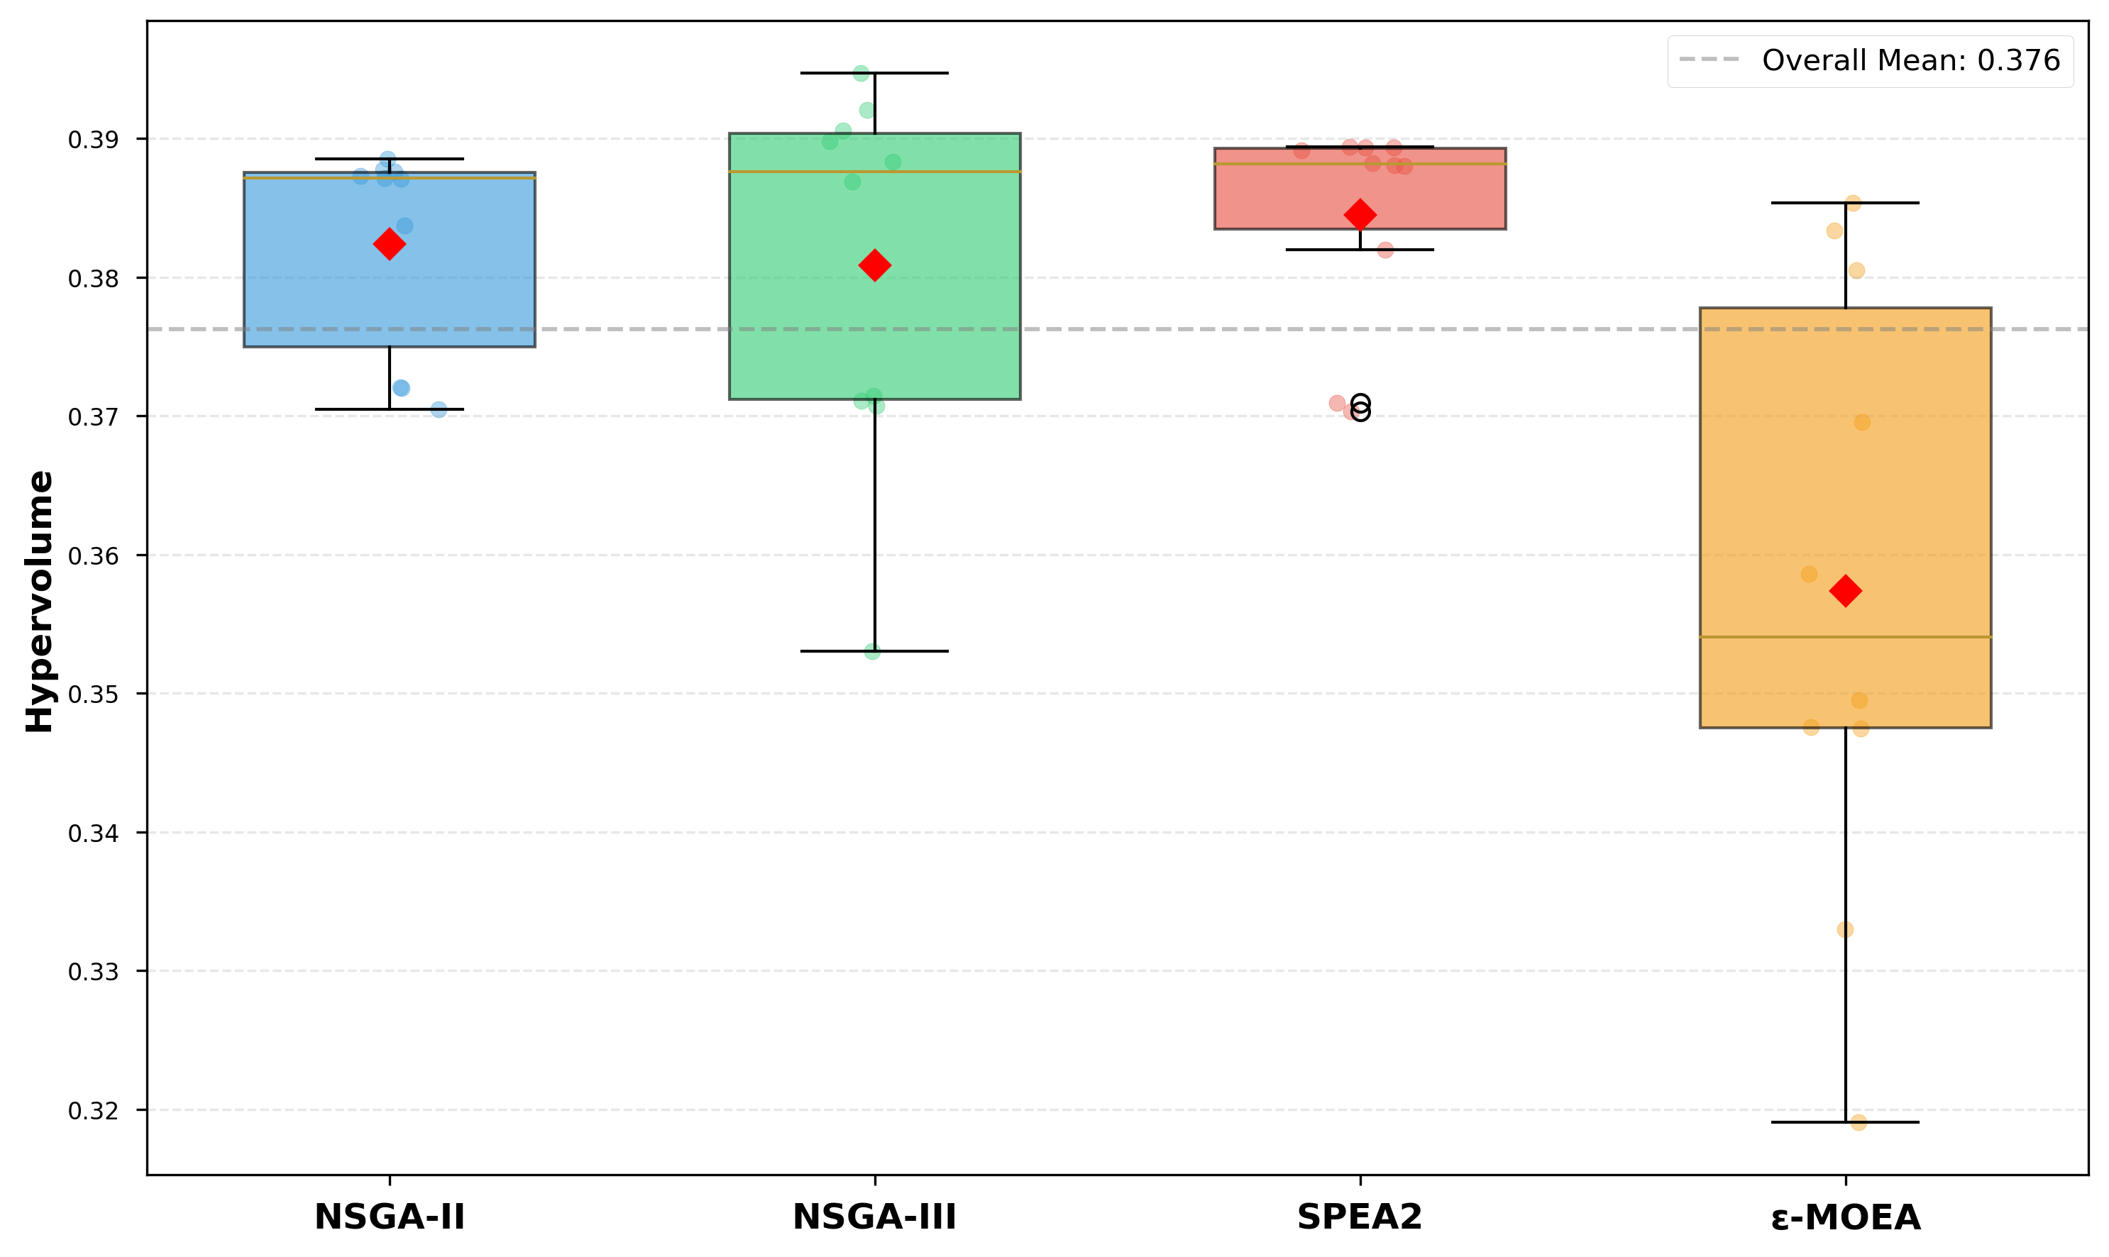
Figure 2. The box plots of hypervolume distributions across 10 independent runs for each algorithm. Red diamonds indicate mean values, horizontal lines represent medians, box boundaries denote the 25th and 75th percentiles (interquartile range, IQR), and whiskers extend to the most extreme data points within 1.5 times the IQR. The overall mean across all algorithms (0.376) is marked by a dashed gray line for reference.

SPEA2 and NSGA-II demonstrated remarkably consistent performance, with narrow interquartile ranges and complete absence of outliers (Figure 2). SPEA2's median (0.385) slightly exceeds NSGA-II's (0.382), though both distributions significantly overlap, indicating minimal practical difference in optimization quality. The tight clustering of SPEA2's hypervolume values reflects stabile performance across different initial conditions.
NSGA-III exhibited greater variability with a standard deviation of 0.013 compared to NSGA-II (0.007) and SPEA2 (0.007), a slightly lower median (0.381), and two mild outliers below 0.371. This increased variance suggests that NSGA-III's performance may be more sensitive to initial population randomness or reference point configuration. Nevertheless, the median performance remains competitive with the top performers, indicating that the majority of runs achieve satisfactory optimization quality comparable to NSGA-II and SPEA2.
ε-MOEA showed pronounced underperformance and instability, with the lowest median (0.354), widest interquartile range spanning nearly 0.06 units, and multiple outliers both above and below the whiskers. The mean (0.357) falls substantially below the overall average of 0.376, confirming that ε-MOEA consistently fails to achieve competitive hypervolume within 100 generations regardless of initial conditions. The high variability reflects inconsistent optimization quality across runs, with hypervolume ranging from as low as 0.33 to approaching 0.37.
Statistical analysis using Kruskal-Wallis H-test confirmed significant differences among algorithms (H = 14.407, p = 0.0024). Pairwise Mann-Whitney U tests with Bonferroni correction (α = 0.0083) revealed that SPEA2, NSGA-II, and NSGA-III achieved statistically equivalent hypervolume performance: NSGA-II versus NSGA-III (p = 0.678, Cliff's δ = +0.080), NSGA-II versus SPEA2 (p = 0.121, δ = -0.280), and NSGA-III versus SPEA2 (p = 0.791, δ = -0.060). In contrast, ε-MOEA was significantly inferior to all three leading algorithms: SPEA2 versus ε-MOEA (p = 0.0017, δ = +0.840), indicating that in 92% of pairwise comparisons, SPEA2's hypervolume exceeded ε-MOEA's. These results confirm that the three leading algorithms achieve comparable optimization quality, suggesting that selection should prioritize secondary factors such as computational efficiency or solution uniformity rather than hypervolume.

Computational Efficiency
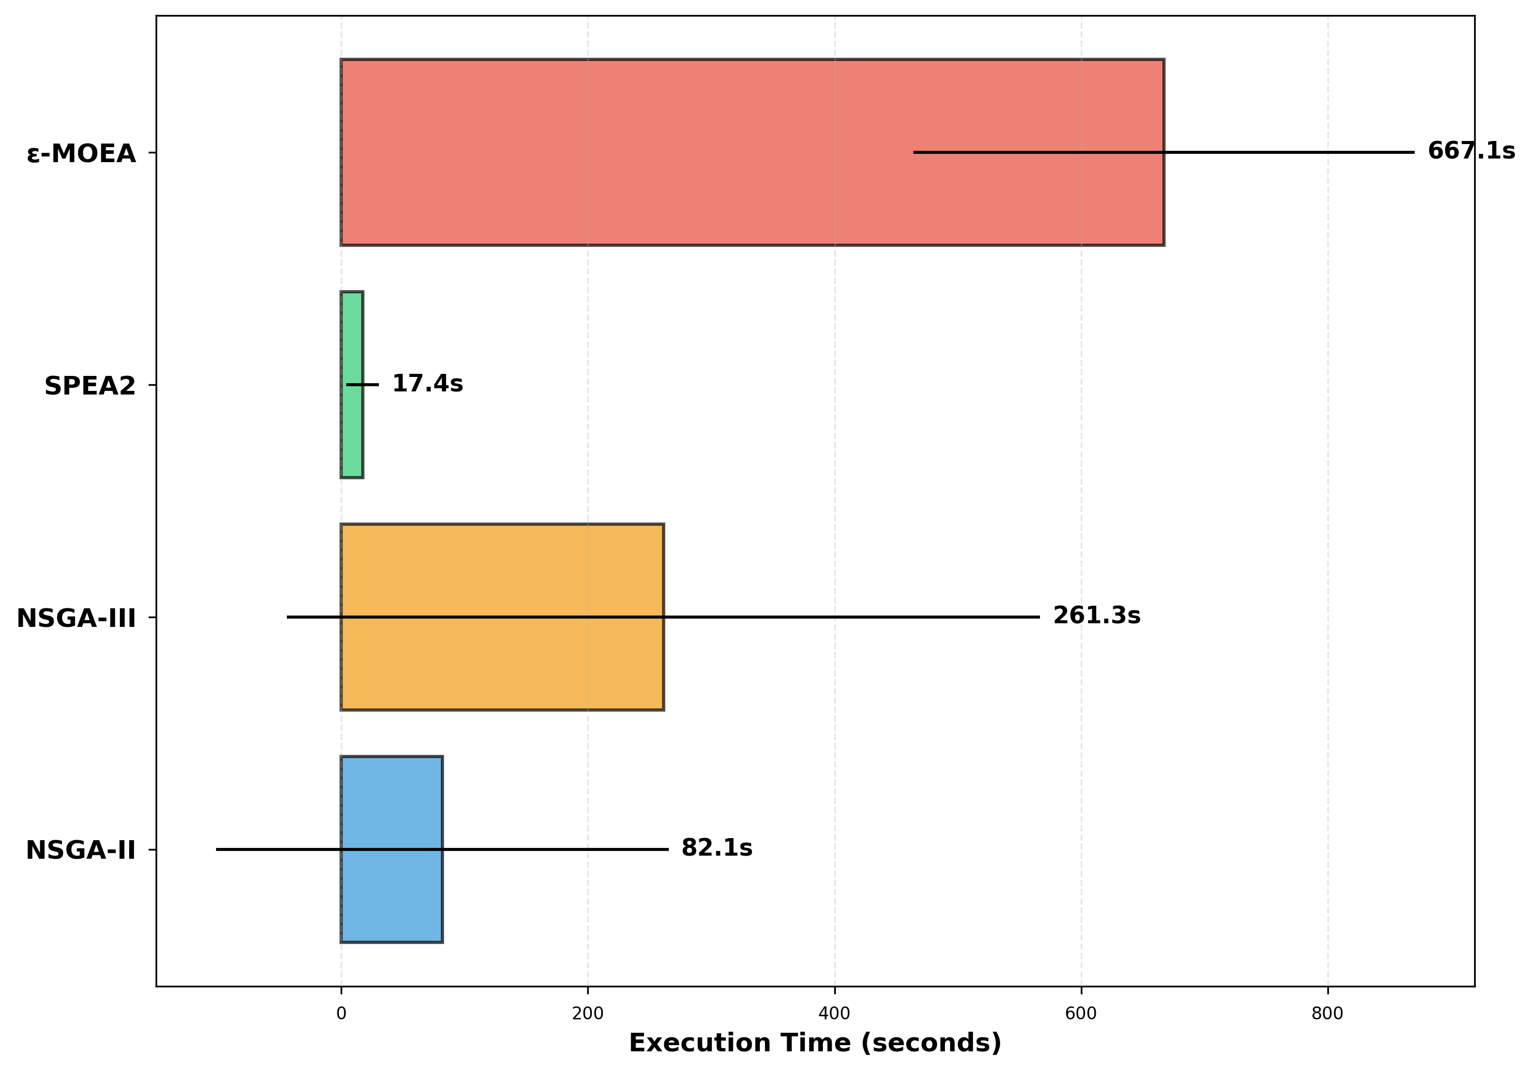
Figure 3. The comparison of execution times using horizontal bar charts with error bars representing plus or minus one standard deviation. Relative slowdown factors compared to SPEA2 are annotated on each bar to facilitate interpretation of performance differences.

SPEA2 demonstrated exceptional computational efficiency, completing optimization in an average of 17.4 ± 13.4 seconds. The low standard deviation (13.4 seconds, 77% of the mean) indicates stable, predictable runtime—a critical advantage for production systems where service level agreements or user experience requirements demand consistent response times.
NSGA-II exhibited moderate speed with an average execution time of 82.1 ± 183.4 seconds, running 4.7 times slower than SPEA2. However, the extremely large standard deviation (183.4 seconds, which is 2.2 times the mean) reveals high runtime variability. Some runs completed in under 20 seconds, comparable to SPEA2's performance, while others exceeded 600 seconds—a 30-fold difference.
NSGA-III was substantially slower with an average execution time of 261.3 ± 305.4 seconds, running 15.0 times slower than SPEA2. Similar to NSGA-II, NSGA-III exhibits large runtime variance with a standard deviation of 305.4 seconds (117% of the mean), further limiting its suitability for time-critical applications.
ε-MOEA suffered from prohibitive execution time with an average of 667.1 ± 203.4 seconds (over 11 minutes), running 38.4 times slower than SPEA2. Despite being the slowest, ε-MOEA shows the most consistent runtime with a standard deviation of 203.4 seconds representing only 30% of the mean.
Kruskal-Wallis H-test revealed highly significant differences in execution time among algorithms (H = 24.686, p < 0.001). Pairwise comparisons confirmed SPEA2's dramatic computational advantage over all competitors with perfect or near-perfect effect sizes: SPEA2 versus NSGA-II (p < 0.001, Cliff's δ = -0.980), SPEA2 versus NSGA-III (p < 0.001, δ = -0.920), and SPEA2 versus ε-MOEA (p < 0.001, δ = -1.000). The perfect separation for SPEA2 versus ε-MOEA indicates that SPEA2 was faster in 100% of trials across all 10 independent runs. These statistical results confirm that SPEA2's computational efficiency superiority is both statistically significant and practically transformative for real-world deployment, where response time directly impacts user experience and operational costs (Nielsen, 1993; Card et al., 1983).

Algorithm Selection for System Implementation
Based on comprehensive performance evaluation and statistical validation, SPEA2 was selected as the optimization engine for the MENTOR system deployed in elderly care facilities. SPEA2 achieved the highest optimization quality (hypervolume: 0.384 ± 0.007) with exceptional consistency, ensuring that the system reliably generates high-quality meal plans that effectively balance nutritional adequacy, cost effectiveness, menu harmony, and dietary diversity. Statistical analysis confirmed that SPEA2's hypervolume performance is equivalent to NSGA-II and NSGA-III (p > 0.1) while significantly superior to ε-MOEA (p = 0.0017, δ = +0.840), establishing it among the top-performing algorithms without compromise in solution quality. Also, its computational efficiency (17.4 ± 13.4 seconds) enables responsive system performance essential for interactive dietary planning workflows. In contrast, NSGA-II's high runtime variance (SD: 183.4 seconds) and NSGA-III's substantially longer execution time (261.3 seconds) would introduce delays that disrupt workflow efficiency. Statistical validation confirmed SPEA2's dramatic speed advantage across all comparisons (p < 0.001, δ ≈ -1.0), with perfect separation from ε-MOEA indicating 100% reliability in faster completion. Its stable and predictable performance ensures consistent system behavior across diverse usage scenarios, which is critical for building user trust and confidence in the system's recommendations. The algorithm's reliability was demonstrated through consistent hypervolume (SD: 0.007) and execution time (SD: 13.4 seconds) across all 10 independent runs. While NSGA-III achieved statistically superior solution uniformity (spacing: 0.388 vs. SPEA2's 0.436, p = 0.096 marginally significant), this 11% advantage was deemed insufficient to justify its 15-fold computational cost increase. Analysis revealed that SPEA2's solution distribution provides adequate coverage of the Pareto front for practical decision support (Figure 4), with no substantial gaps that would limit nutritionists' access to desired trade-off regions.

Field Deployment and Usability Evaluation

Solution Distribution and Trade-off Visualization

Discussion

Conclusion

References
1 Ordovas JM, Berciano S. Personalized nutrition and healthy aging. Nutr Rev. 2020;78:58–65. doi: 10.1093/nutrit/nuaa102
2 Ruthsatz M, Candeias V. Non-communicable disease prevention, nutrition and aging. Acta Biomed. 2020;91:379–88. doi: 10.23750/abm.v91i2.9721
3 Kimokoti RW, Millen BE. Nutrition for the Prevention of Chronic Diseases. Medical Clinics of North America. 2016;100:1185–98. doi: 10.1016/j.mcna.2016.06.003
4 Singh VK, Hu X-H, Singh AK, et al. Precision nutrition-based strategy for management of human diseases and healthy aging: current progress and challenges forward. Front Nutr. 2024;11. doi: 10.3389/fnut.2024.1427608
5 Alian S, Li J, Pandey V. A Personalized Recommendation System to Support Diabetes Self-Management for American Indians. IEEE Access. 2018;6:73041–51. doi: 10.1109/ACCESS.2018.2882138
6 Arias-Marroquín AT, Del Razo-Olvera FM, Castañeda-Bernal ZM, et al. Personalized Versus Non-personalized Nutritional Recommendations/Interventions for Type 2 Diabetes Mellitus Remission: A Narrative Review. Diabetes Therapy. 2024;15:749–61. doi: 10.1007/s13300-024-01545-2
7 Padovan M, de Senna FR, Kimura JK, et al. Optimized menu formulation to enhance nutritional goals: design of a mixed integer programming model for the workers’ food program in Brazil. BMC Nutr. 2023;9:51. doi: 10.1186/s40795-023-00705-0
8 Eghbali-Zarch M, Tavakkoli-Moghaddam R, Esfahanian F, et al. A new multi-objective optimization model for diet planning of diabetes patients under uncertainty. Health Education and Health Promotion. 2017;5:37–55.
9 Masters WA, Bai Y, Herforth A, et al. Measuring the Affordability of Nutritious Diets in Africa: Price Indexes for Diet Diversity and the Cost of Nutrient Adequacy. Am J Agric Econ. 2018;100:1285–301. doi: 10.1093/ajae/aay059
10 Parlesak A, Tetens I, Dejgård Jensen J, et al. Use of Linear Programming to Develop Cost-Minimized Nutritionally Adequate Health Promoting Food Baskets. PLoS One. 2016;11:e0163411. doi: 10.1371/journal.pone.0163411
11 Veiros MB, Da Costa Proença RP, Kent‐Smith L, et al. How to analyse and develop healthy menus in foodservice. Journal of Foodservice. 2006;17:159–65. doi: 10.1111/j.1745-4506.2006.00025.x
12 Robert O F, Lauren F S. Linear Programming: Fundamentals and Applications. McGraw-Hill 1958.
13 Wilson N, Nghiem N, Ni Mhurchu C, et al. Foods and Dietary Patterns That Are Healthy, Low-Cost, and Environmentally Sustainable: A Case Study of Optimization Modeling for New Zealand. PLoS One. 2013;8:e59648. doi: 10.1371/journal.pone.0059648
14 Perignon M, Masset G, Ferrari G, et al. How low can dietary greenhouse gas emissions be reduced without impairing nutritional adequacy, affordability and acceptability of the diet? A modelling study to guide sustainable food choices. Public Health Nutr. 2016;19:2662–74. doi: 10.1017/S1368980016000653
15 Koenen MF, Balvert M, Fleuren H. Bi-objective goal programming for balancing costs vs. nutritional adequacy. Front Nutr. 2022;9. doi: 10.3389/fnut.2022.1056205
16 Soares TF, Escarpinati MC, Gabriel PHR. MULTI-OBJECTIVE OPTIMIZATION APPLIED TO DIET PLANNING FOR PEOPLE WITH DIABETES. Pesquisa Operacional. 2024;44. doi: 10.1590/0101-7438.2023.043.00285156
17 Stigler GJ. The Cost of Subsistence. Journal of Farm Economics. 1945;27:303. doi: 10.2307/1231810
18 Garille SG, Gass SI. Stigler’s Diet Problem Revisited. Oper Res. 2001;49:1–13. doi: 10.1287/opre.49.1.1.11187
19 Dantzig GB. The Diet Problem. Interfaces (Providence). 1990;20:43–7. doi: 10.1287/inte.20.4.43
20 Sklan D, Dariel I. Diet planning for humans using mixed-integer linear programming. British Journal of Nutrition. 1993;70:27–35. doi: 10.1079/BJN19930102
21 van Dooren C. A Review of the Use of Linear Programming to Optimize Diets, Nutritiously, Economically and Environmentally. Front Nutr. 2018;5. doi: 10.3389/fnut.2018.00048
22 Maillot M, Vieux F, Amiot MJ, et al. Individual diet modeling translates nutrient recommendations into realistic and individual-specific food choices. Am J Clin Nutr. 2010;91:421–30. doi: 10.3945/ajcn.2009.28426
23 Horgan GW, Perrin A, Whybrow S, et al. Achieving dietary recommendations and reducing greenhouse gas emissions: modelling diets to minimise the change from current intakes. International Journal of Behavioral Nutrition and Physical Activity. 2016;13:46. doi: 10.1186/s12966-016-0370-1
24 Kesse-Guyot E, Fouillet H, Baudry J, et al. Halving food-related greenhouse gas emissions can be achieved by redistributing meat consumption: Progressive optimization results of the NutriNet-Santé cohort. Science of The Total Environment. 2021;789:147901. doi: 10.1016/j.scitotenv.2021.147901
25 Abejón R, Batlle-Bayer L, Laso J, et al. Multi-Objective Optimization of Nutritional, Environmental and Economic Aspects of Diets Applied to the Spanish Context. Foods. 2020;9:1677. doi: 10.3390/foods9111677
26 Türkmenoğlu C, Etaner Uyar AŞ, Kiraz B. Recommending healthy meal plans by optimising nature-inspired many-objective diet problem. Health Informatics J. 2021;27. doi: 10.1177/1460458220976719
27 Seljak BK. Dietary Menu Planning Using an Evolutionary Method. 2006 International Conference on Intelligent Engineering Systems. IEEE :108–13.
28 Cholissodin I, Dewi RK. Optimization of Healthy Diet Menu Variation using PSO-SA. Journal of Information Technology and Computer Science. 2017;2:28–40. doi: 10.25126/jitecs.20172129
29 Ahourag A, El Moutaouakil K, Elkari B, et al. A Multiobjective Diet Planning Model for Diabetic Patients in the Moroccan Health Context Using Particle Swarm Intelligence. Statistics, Optimization & Information Computing. 2024;12:605–16. doi: 10.19139/soic-2310-5070-1947
30 Verma S, Pant M, Snasel V. A Comprehensive Review on NSGA-II for Multi-Objective Combinatorial Optimization Problems. IEEE Access. 2021;9:57757–91. doi: 10.1109/ACCESS.2021.3070634
31 Deb K, Jain H. An Evolutionary Many-Objective Optimization Algorithm Using Reference-Point-Based Nondominated Sorting Approach, Part I: Solving Problems With Box Constraints. IEEE Transactions on Evolutionary Computation. 2014;18:577–601. doi: 10.1109/TEVC.2013.2281535
32 Altınöz OTolga. Designing Diet Program That Balancing Nutritional Adequacy with Environmental Sustainability by Using Multi-Objective Optimization. 4th International Conference on Trends in Advanced Research. 2025;319–31.

